USB TEster Siddhant Sunil Joshi

**Overview**:

                            We often see that due to some electrical flotations or due to any mechanical shock device get damage which further leads to the cause of creation unwanted accident like an electrical shock, defeat cause in other devices connected to it, etc. to reduce this damage especially with the USB Female connector we come up with a device which can check the compatibility of that socket I to get to send data or to receive data **USB Tester**

**Circuit Diagram:**

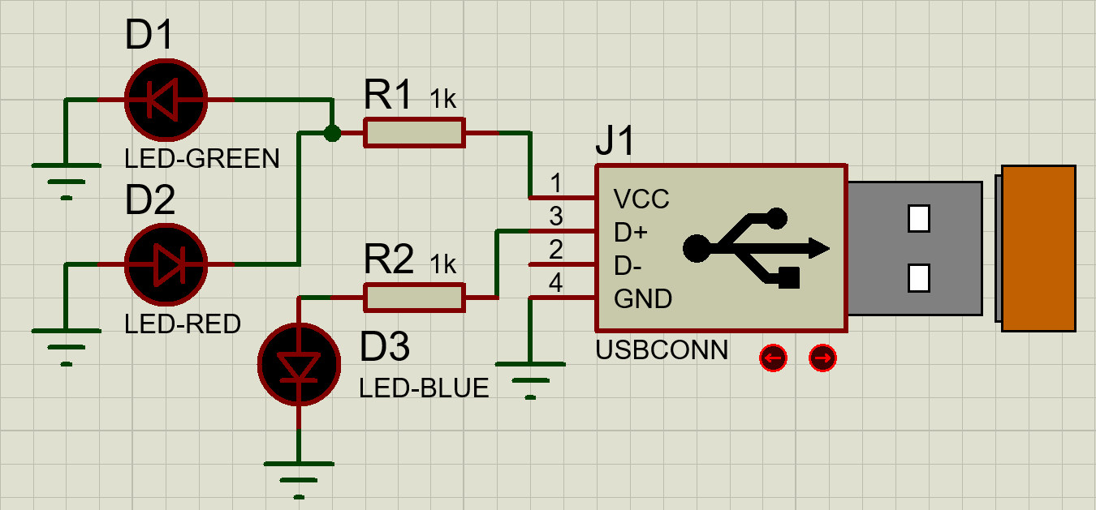

Figure 1 Circuit Diagram

**Calculations:**

We have applied voltage **Vin** as **5V** and we have resistor connected to LED as **1.0 K** thus by using Ohm’s law

$$I=\frac{Vin}{R}$$

$$I=5 mili amp$$

Thus we get 5m amp current which is moderate value for LED to glow in proper range thus no need of any defect.

USB TEster Siddhant Sunil Joshi

**PCB Design:**

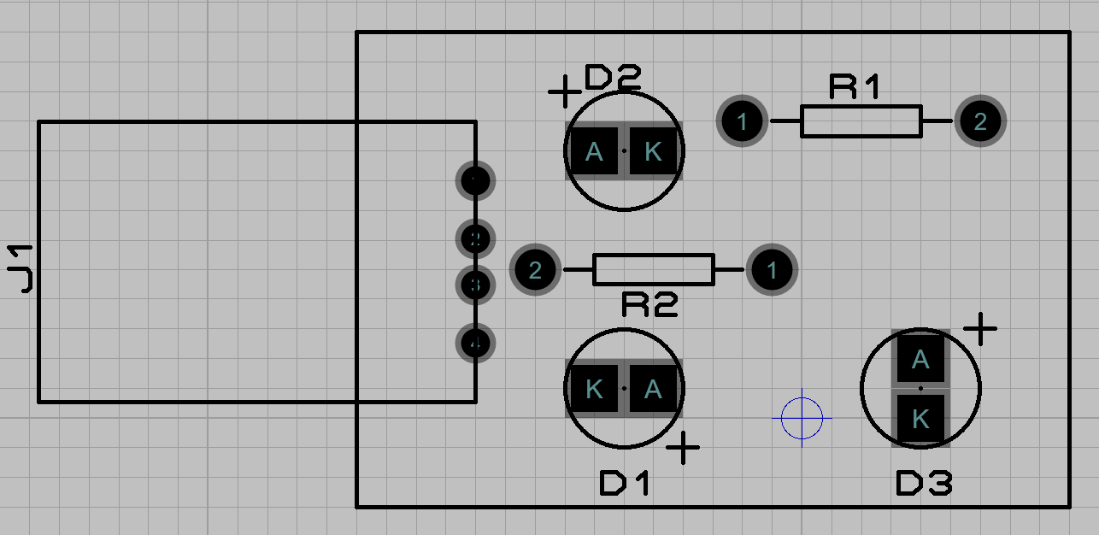

Figure 2 PCB Design

**3D visualization of system**

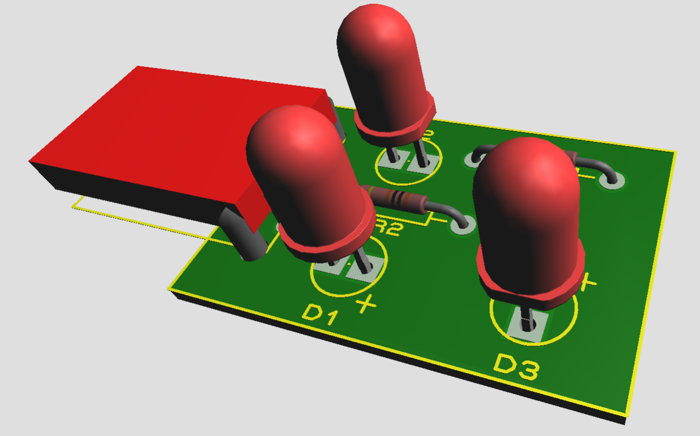

Figure 3 3D Image of System